Sprint 1 Plan

Product Name : UpToDate

Team Name: UpToDaters

Release Name : UpToDate

Release Date : 3/19/18

Revision Number : 2

Revision Date : 2/28/18

Goal: Design the architecture flow, get familiar with Python and its frameworks, set up barebones website

Task Listing

* User Story 1: As a user, I want to familiarize myself with Python and prepare myself enough to code a project comfortably in this language
  + Read tutorials and watch videos to familiarize self with Python (10 points)
* User Story 2: As a user, I want to have a centralized homepage (5 points)
  + Design a front end page where content will be displayed(2 hours)
  + Connect frontend user input to backend (5 hours)

Team Roles

* Team Member Manav Sharma: Product Owner
* Team Member Tariq Anees: Scrum Master
* Team Member Andrew Boyadjiev: Developer
* Team Member Arthur Kang: Developer
* Team Member Tommy Tran: Developer
* Team Member Vanessa Tan: Developer

Initial Burn Up Chart

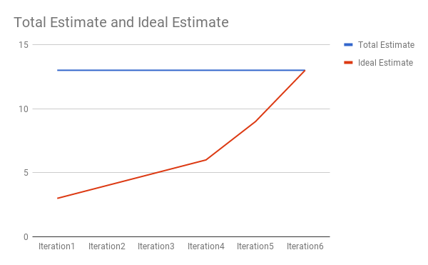

Initial Scrum Board

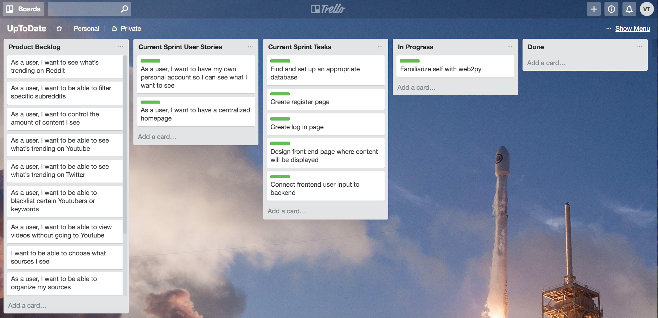

Scrum Times

* Monday at 11:30 am (TA visit)
* Wednesday at 9:00 am
* Friday at 9:00 am